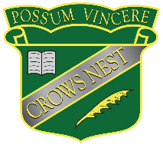
Crow’s Nest State School

Primary SRS Fee Payment Arrangement Form

Section 1: Student Details
Student Name
Student ID
Year Level

Section 2: SRS Category
SRS Category | SRS Fee Payable
Primary SRS | $60.00

Section 3: Payment Arrangement
Please select the preferred payment options:
Payment options | Instalments | Amounts | Option Selected
- A single payment for the full year’s fee  (Invoiced Term 1) | Instalment 1: | $60.00 | ☐
- Term instalments  (Invoiced Term 1 & Term 3) | Instalment 1:  Instalment 2: | $30.00 | ☐
- An instalment plan as negotiated with the school | Please contact the school office

Section 4: Return of the Participation Form
Parents are reminded to complete and return the SRS Participation Agreement Form when joining the scheme for the first time or opting in/out during the student’s enrolment.
Have you completed and returned the SRS Participation Agreement Form? | Yes ☐ | No ☐
Please note if you choose to opt out of the SRS, you are still required to complete and return the Participation Agreement Form.

Section 5: Parent Signature
Parent Name
Parent Signature
Date

